SPRINGFIELD PARISH COUNCIL
MINUTES OF THE FINANCE & POLICY MEETING
HELD 11TH NOVEMBER 2019 AT 7.00P.M.
PARISH CENTRE CM1 6GX

Cllrs: Ms S Byrne-Lagrue, Mrs C Garrett, R Lee, Mrs Y Spence (Chairman) and Ms S Sullivan.

In attendance: Cllr M. Girling and the Clerk to the Council.

26 APOLOGIES FOR ABSENCE – were received from Cllr N Gulliver.

27 MINUTES OF THE COMMITTEE MEETING HELD ON 4th September 2019
(Copy circulated with agenda for full council meeting – 30th September 2019)

RESOLVED: that the minutes of the meeting be signed as a correct record.

28 DECLARATIONS OF INTEREST & DISPENSATIONS

Cllr Byrne-Lagrue declared a non-pecuniary interest in the Springfield Youth Club.

29 CO-OPTION OF NON-COMMITTEE MEMBERS – there were none.

30 QUESTIONS FROM MEMBERS OF THE PUBLIC & PRESS – there were none in attendance.

31 RISK ASSESSMENTS

(a) Work Unit & Equipment – no significant risks to report.

(b) Parish Council Offices – no significant risks to report

RESOLVED: the information is noted.

32 FINANCIAL MATTERS

32.1 Budget Report

Members received the budget report attached as appendix A from July to September 2019.

RESOLVED: the information is noted.

32.2 Bank Balances & Investments

Members received the statement of the Council’s bank accounts and investments as follows:

Current A/c (27 Sept) £ 50,000
Business Premium A/c (27 Sept) £ 395,449
Charity Churches & Local Authorities (CCLA 30 Sept) £ 310,707
Nat West (28 Aug) £ 153,050

RESOLVED: that the information is noted.

32.3 External Audit 2018 / 2019

RESOLVED: that further to minute 23.3 of the Finance & Policy committee meeting on 4th September 2019, members noted PFK Littlejohn, external auditors, had now completed the 2018/19-year end accounts (AGAR). One matter had been raised that the Box 6 figure should read £486,467 (to include the CCLA investment); the end of audit notification had been posted accordingly.

32.4 Interim Audit 2019 / 2020

RESOLVED: that (a) members received the report of Heelis & Lodge, internal auditors, for the present year (2019/20) on 23rd October 2019.

(b) the report was noted and is attached as appendix B with one recommendation to re-state the figures in the box 6 AGAR at year end.

33 PRECEPT 2020/21

33.1 Finance & Policy Committee Budget 2020/21 (including Earmarked Reserve Balances)

Members considered the committee budget in the sum of £239,615 for the 2020/21 financial year. RESOLVED: that (a) the Finance & Policy committee budget in the sum of £239,615 attached at appendix C be approved;

(b) the EMR vehicle fund (NC 3130) is increased by £2,000 at commencement of next financial year to provide a fund total of £7,000;

(c) £10,000 of CIL tax will be earmarked (projects tab in SAGE) towards future expenditure on retaining the library service at the parish centre

33.2 Committee Budgets 2020/21
Members considered the budget requests from each committee.

a) Premises £35,322.86
b) Environment & Leisure £28,104.00

RESOLVED: that the committee budgets be approved.

33.3 Precept Requirement 2020 / 21

RESOLVED: that the total precept requirement to be submitted to Chelmsford City Council will be £387,242 for the financial year 2020/21 as detailed at appendix D.

34 Camera

Members considered the purchase of a new camera for the Council. The present camera is exceptionally old and can only accommodate taking 10 photographs at any one time.

RESOLVED: that Cllr R. Lee would examine the present camera to see whether its use can be continued.

35 CCTV System

At the parish council meeting on 15th April 2019, it was agreed that the installation of a new CCTV system at the parish centre should be included in the list of projects for expenditure from CIL Tax contributions. The parish centre committee discussed the CCTV installation at their meeting on 24th September where it was approved that quotations would be obtained.

RESOLVED: that authorisation is given for the CCTV installation to be financed from CIL Tax. Committed spending to date was noted (Automatic doors 4,917 fencing at front of Centre 3,156 Defib +electrical 706) Balance of fund = £70,228. A sum not exceeding £14,000 will be allocated to the installation of CCTV at the Parish Centre to cover internal and external areas of the premises.

36 POLICIES

Members reviewed the following parish council policies:
- Health & Safety Policy & Statement – ladder report and sign.
- Complaints Procedure – Nos. 4 & 5 swapped.
- Document Retention - no change
- Environmental Statement – electric vehicles to be added to the statement.
- Code of Conduct - Members to note that there have been no legislation changes that affect this policy.

RESOLVED: that (a) it was noted a ladder report/register will be placed in the Centre office for use by staff and the general policy statement to be signed by the Chariman of the Council;

(b) the policies be updated as above.

37 PERSONNEL SUB COMMITTEE

37.1 Minutes of Meeting held 10th October 2019

RESOLVED: a copy of the minutes of the meeting held on 10th October 2019 were received and approved.

37.2 Vacancy on Committee

Cllr Byrne-Lagrue had resigned from the Personnel Sub-Committee.

RESOLVED: that Cllr M. Girling be appointed to the personnel committee.

38 EXCLUSION OF PRESSS AND PUBLIC

RESOLVED: that in accordance with the Admissions to Meetings Act 1960, the public and press were excluded.

39 PARISH COUNCIL WEBSITE

Further to minute 24 of the Finance & Policy Committee Meeting on 4th July 2019, Members received information and costs concerning the setting up, hosting and staff training of a website that will be compliant with the Disability Access legislation.

RESOLVED: that Sue Lees consultancy be appointed to set up, train staff, carry out ad-hoc maintenance when required and twice-yearly updates of the site.

Cllr Y. Spence
Meeting closed 8.00p.m.

Signed……………………………………………………. Date ……………………………………..

APPENDIX A
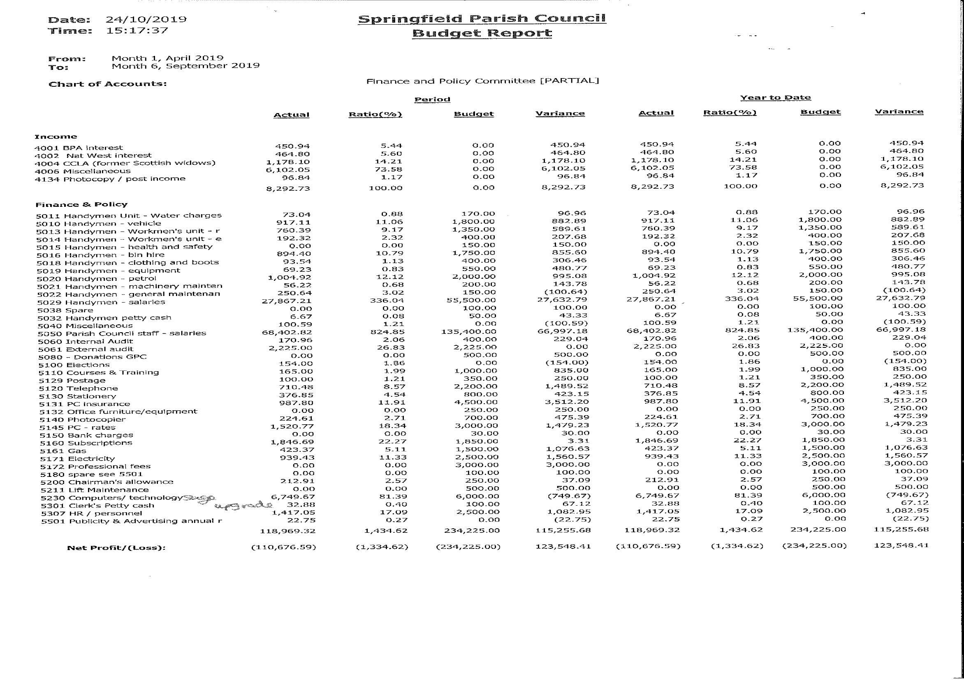

Appendix B
HEELIS&LODGE

Local Council Services • Internal Audit

Interim Internal Audit Report for Springfield Parish Council – 2019/2020

The following Internal Audit was carried out on the adequacy of systems of control. The following recommendations/comments have been made:

Proper book-keeping Cash Book, regular reconciliation of books and bank statements. Supporting vouchers, invoices and receipts

All were found to be in order. VAT payments are tracked and identified within the cashbook. The Council operate under the General Power of Competence and therefore LGAs137 is not applicable. The cashbook (Sage Accounts) is referenced providing a clear audit trail. Supporting paperwork is in place and well referenced. All supplier invoices are well referenced through a payment authorisation slip which provides a thorough audit trail from purchase order to payment.

Financial regulations Standing Orders and Financial Regulations
Tenders
Appropriate payment controls including acting within the legal framework with reference to council minutes
Identifying VAT payments and reclamation
Cheque books, paying in books and other relevant documents

Standing Orders in place: Yes
Reviewed: 10/6/2019 (Ref: 14.1)
Financial Regulations in place: Yes
Reviewed: 18/2/2019 (Ref: 33.2)

VAT reclaimed during the year: Yes Registered: Yes

General Power of Competence: Yes (adopted 14/5/2019 – item 13)

Tenders exceeding the £25,000 threshold are advertised on the Contract Finders website.

Risk Assessment Appropriate procedures in place for the activities of the council
Compliance with Data Protection regulations

Risk Assessment document in place: Yes
Data Protection registration: Yes

Data Protection
The General Data Protection Regulations have changed and the new Regulations came into force on 25 May 2018. It is likely that this will affect the way in which the Council handles its data. Due to the financial risk associated with the General Data Protection Regulations, the Council have included this in their Risk Assessment.

Privacy Policy published: Yes

Insurance was in place for the year of audit. The effectiveness of Internal Controls was reviewed at a meeting held on 17/6/2019 (Ref: 26).

The Council have effective ongoing risk management processes through the Committee structure.

The following policies have been reviewed during the year:

      - Social Media
      - Employee Handbook
      - Capability Policy (new policy)

The Council have good internal financial controls in place. Cheque stubbs and invoices are initialled by signatories. The Clerk provides financial reports to council meetings. Councillors are provided with information to enable them to make informed decisions.

The Annual Fire Risk Assessment has been updated to reflect ongoing maintenance works carried out around the Parish Centre (Ref: 24/9/2019 – item 54).

Bank signatories were confirmed at a meeting held on 10/6/2019 (Ref: 7.4).

Fidelity Cover: £500,000

The level of Fidelity cover is within the recommended guidelines of year end balances plus 50% of the precept.

Transparency Code Compliance for smaller councils with income/expenditure under £25,000.
Smaller authorities should publish on their website from 1 April 2015:

Smaller Council: No
Website: www.essexinfo.net/springfieldparishcouncil

The Council is not subject to the requirements of the Transparency Code for smaller Councils. The Transparency Code for Councils with a turnover exceeding £200,000 is not covered as part of the Internal Audit.

Budgetary controls Verifying the budgetary process with reference to council minutes and supporting documents

Precept: £383,146 (2019-2020) Date: 10/12/2019 (Ref: 66)

Good budgetary procedures are in place. The precept was agreed in full council and the precept decision and amount has been clearly minuted. The Clerk ensures the council are aware of responsibilities, commitments, forward planning and the need for adequate reserves. Budget papers are prepared to ensure councillors have sufficient information to make informed decisions. Budgets are monitored during the year.

Income controls Precept and other income, including credit control mechanisms

Hire agreements have been reviewed and terms updated (Ref: 24/9/2019 – item 71).

Petty Cash Associated books and established system in place

A satisfactory petty cash system is in place with supporting paperwork. A sample of receipts were examined and cross referenced with vouchers and the cash book. Petty cash is reconciled on a regular basis.

Payroll controls PAYE and NIC in place where necessary.
Compliance with Inland Revenue procedures
Records relating to contracts of employment

PAYE System in place: Yes

To be examined at the year end.

It is noted that the Council undertook a review of staff contracts at a meeting held on 1/7/2019 (Ref: 5).

Asset control Inspection of asset register and checks on existence of assets
Cross checking on insurance cover To be carried out at the year end.

Bank Reconciliation Regularly completed and cash books reconcile with bank statements

All were in order. Bank Reconciliations are carried out regularly. The bank statements reconciled with the accounts and bank reconciliations for all accounts.

Bank Balances at 30/9/2019 were confirmed as:
CCLA xxxx8000 £310,707.34
Barclays xxxx9404 £50,000.00
Barclays BP xxxx6332 £395,449.00
NatWest xxxx4315 £153,050.46 (31/8/2019)

Reserves General Reserves are reasonable for the activities of the Council
Earmarked Reserves are identified. To be carried out at the year end.

Year-end procedures Appropriate accounting procedures are used and can be followed through from working papers to final documents
Verifying sample payments and income
Checking creditors and debtors where appropriate.

To be carried out at the year end.

Sole Trustee The Council has met its responsibilities as a trustee

The Council is not a sole trustee.

Internal Audit
Procedures The Year End 2019 Internal Audit report was considered by the Council at a meeting held on 10/6/2019 (Ref: 7.1).

A review of the effectiveness of the Internal Audit was carried out on 18/2/2019 (Ref: 33.1.c).

Heelis & Lodge were appointed as Internal Auditor at a meeting held on 18/2/2019 (Ref: 33.1.b).

External Audit The External Auditor’s report is due to be considered at a meeting held on 11/11/2019.

The following matters were brought to the attention of the Council:

To include the CCLA balance (now classed as an asset) in Box 6 as a payment.

Recommendation: To restate the 2019 figures in the 2020 AGAR.

Period of Exercise of Public Rights Start Date 18/6/2019 (2018-2019)

Additional Comments/Recommendations

- The Annual Parish Council meeting was held on 14/5/2018, within the required timescale. The first item of business was the Election of Chairman, in accordance with Standing Orders.
- There are no additional comments/recommendations to make in relation to this audit.
- I would like to record my appreciation to the Clerk to the Council for her assistance during the course of the audit work
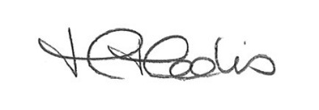

Heather Heelis
Heelis & Lodge
23 October 2019
 | COMMITTEE | 2020 /21(next year)
27,594 | Environment & Leisure | 28,104
32,409 | Premises | 35,323
234,225 | Policy & Finance | 239,615
3,450 | Events & Projects | Committee disbanded
70,468 | Public Works Loans (x3) | 69,200
368,146 | SUB TOTAL | 372,242
15,000 | Beaulieu Community Centre | 15,000
£386,801  = £52.62 7350.54 Tax Base | Band D £52.68  Not confirmed  By C.C.C | £387,242

Appendix D

